**Graph code**

1. Fig-1

import matplotlib.pyplot

import numpy

city = ['Dhaka', 'Rajshahi', 'Borishal', 'Khulna']

population = [10.4, 6.7, 8.90, 15.2]

figure = matplotlib.pyplot.figure()

figure.patch.set_alpha(.3)

matplotlib.pyplot.plot(city, population)

# matplotlib.pyplot.show()

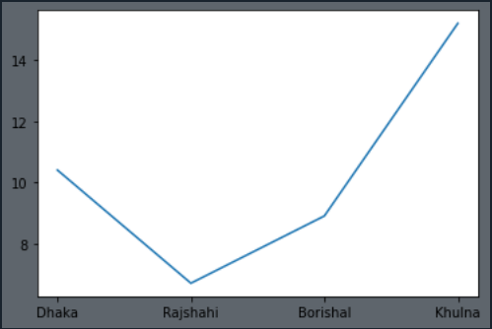

1. Fig-2 (color code)

import matplotlib.pyplot

import numpy

city = ['Dhaka', 'Rajshahi', 'Borishal', 'Khulna']

population1 = [10.4, 6.7, 8.9, 15.2]

population2 = [10.8, 7.1, 9.3, 15.6]

population3 = [11.2, 7.5, 9.7, 16.0]

population4 = [11.6, 7.9, 10.1, 16.4]

population5 = [12.0, 8.13, 10.5, 16.8]

figure = matplotlib.pyplot.figure(figsize=(8, 3), facecolor='w')

# figsize=(X, Y)

'''

color code

green => g

red => r

yellow =>y

black =>

blue => b

white => w

'''

figure.patch.set_alpha(.3)

matplotlib.pyplot.plot(city, population1, 'r')

matplotlib.pyplot.plot(city, population2, 'g')

matplotlib.pyplot.plot(city, population3, 'y')

matplotlib.pyplot.plot(city, population4, 'b')

matplotlib.pyplot.plot(city, population5, 'w')

# plot(X, Y, 'color pointShape')

# matplotlib.pyplot.show()

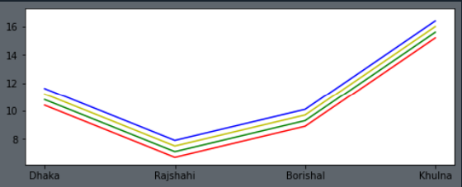

l

1. Fig-3
2. Fig-4
3. Fig-5
4. Fig-6
5. Fig-7
6. Fig-8
7. Fig-9
8. Fig-10
9. Fig-11
10. Fig-12